

**------SUNLIGHT TRACKING SOLAR PANEL-----**

## A PROJECT REPORT

***Submitted by***

| **Arun Jaya Pathi.C.U** | **[21EC013]** |
| --- | --- |
| **Arun Prakash.M** | **[21EC014]** |
| **DineshKumar.R** | **[21EC035]** |
| **Aravinth Raja.S.C** | **[21EC011]** |

**BACHELOR OF ENGINEERING**

## in

**ELECTRONICS AND COMMUNICATION ENGINEERING**

**Sri Eshwar College of Engineering**

**(An Autonomous Institution)**

**COIMBATORE – 641 202**

**MAY 2023**

i

**BONAFIDE CERTIFICATE**

Certified that this project report **“SUNLIGHT TRACKING SOLAR PANEL**” is the bonafide work of

| **Arun Jaya Pathi.C.U** | **[21EC013]** |
| --- | --- |
| **Arun Prakash.M** | **[21EC014]** |
| **DineshKumar.R** | **[21EC035]** |
| **Aravinth Raja.S.C** | **[21EC011]** |

who carried out the project work under my supervision

| …………………………………  **SIGNATURE**  **Dr. N. Shanmugasundaram,**  **M.E., (Ph.D).,**  **HEAD OF THE DEPARTMENT**  Professor & Head,  Department of ECE,  Sri Eshwar College of Engineering,  Kinathukadavu,  Coimbatore-641202. | …………………………………  **SIGNATURE**  **Mr.C.UDHAYA KUMAR,**  **M.E.,(Ph.D).,**  **SUPERVISOR**  Assistant Professor  Department of ECE,  Sri Eshwar College of Engineering,  Kinathukadavu,  Coimbatore-641202. |
| --- | --- |

Submitted for the End Semesterpractical examination – Mini project work viva-voce held on _ _ _ _ _ _ _ _ _ _ _ _

……………………… ………………………

**(Internal Examiner) (External Examiner)**

|  | |  | ii |  | | |
| --- | --- | --- | --- | --- | --- | --- |
| **CHAPTER NO.** | |  | **TABLE OF CONTENTS**  **TITLE** | **PAGE NO.** | | |
|  | |  | |  | | |
|  | | **ABSTRACT** | | **vi** | | |
|  | | **LIST OF COMPONENTS** | | **v** | | |
| **1** | | **LIST OF FIGURES** | | **1** | | |
| **2** | | **INTRODUCTION** | | **2** | | |
|  | | 2.1 | WORKING PROCESS | **6** | | |
|  | | 2.2 | PROBLEM STATEMENT | **9** | | |
| **3** | | **PROPOSED SOLUTION** | | **11** | | |
|  | | 3.1 BLOCK DIAGRAM | | **12** | | |
|  | | 3.2 CIRCUIT DIAGRAM | | **13** | | |
| **4** | | **HARDWARE DESCRIPTION** | | **14** | | |
| **5** | **SOFTWARE DESCRIPTION** | | | | **18** | |
|  | 5.1 SOFTWARE PLATFORM | | | | **18** | |
|  | 5.2 CODING STRUCTURE | | | | **19** | |
| **6** | **RESULT & IMPLEMENTATIONS** | | | | **21** | |
| **7**  **8** | **BENEFITS**  **REFERENCE** | | | | **22**  **23** | |
|  |  | | | | |  |

## Abstract

Solar panel has been used increasingly in recent years to convert solar energy to electrical energy. The solar panel can be used either as a stand-alone system or as a large solar system that is connected to the electricity grids. The earth receives 84 Terawatts of power and our world consumes about 12 Terawatts of power per day.

We are trying to consume more energy from the sun using solar panel. In order to maximize the conversion from solar to electrical energy, the solar panels have to be positioned perpendicular to the sun.

Thus the tracking of the sun’s location and positioning of the solar panel are important. The goal of this project is to design an automatic tracking system, which can locate position of the sun.

The system will consist of light sensing system, microcontroller, gear motor system, and a solar panel. Our system will output up to 40% more energy than solar panels without tracking systems

The Automatic Sun Tracking System (ASTS) was made as a prototype to solve the problem, mentioned above. It is completely automatic and keeps the panel in front of sun until that is visible..

iv

| **LIST OF COMPONENTS** | | | |
| --- | --- | --- | --- |
| **No.** | | **NAME** |  |
| 1 | BREAD BOARD | |  |
| 2 | AM-B CABLE | |  |
| 3 | SERVO MOTOR 9G | |  |

4 MALE TO MALE WIRE

5 FEMALE TO FEMALE WIRES

6 MALE TO FEMALE WIRES

7 ARDUINO

8 SOLAR PANEL

9 POWER ADAPTOR

10 LDR MODULE

11 LDR MODULE

12 BOARD

13 LAPTOP

14 ARDUINO IDE PLATFORM

15 CONNECTRING WIRES

v

**No LIST OF FIGURES**

| 1.1 | SOLAR PANEL |  |
| --- | --- | --- |
| 1.2 | ARDUINO CONNECTION |  |
| 2.1 | WORKING RIGHT SIDE |  |

2.2 WORKING LEFT SIDE

3.1 BLOCK DIAGRAM

3.2 CIRCUIT DIAGRAM

4.1 BREAD BOARD

4.2 ARDUINO

4.3 LDR MODULE

4.4 POWER SUPPLY

4.5 SERVO MOTOR

5.1 ARDUINO IDE

6.1 FINAL OUTPUT

1

**CHAPTER 1**

**INTRODUCTION**

[Solar panels are **devices that collect sunlight and turn it into usable electricity**](https://www.bing.com/ck/a?!&&p=c1584326dd778188JmltdHM9MTY4MzMzMTIwMCZpZ3VpZD0wYjg3ZmU1Mi01NDRiLTZjZTEtMmI0NS1lY2FlNTU5OTZkNzMmaW5zaWQ9NTgwOA&ptn=3&hsh=3&fclid=0b87fe52-544b-6ce1-2b45-ecae55996d73&psq=about+solar+panels+information&u=a1aHR0cHM6Ly93d3cuZW5lcmd5c2FnZS5jb20vc29sYXIvc29sYXItMTAxLw&ntb=1). [They are usually made of solar cells, which are composed of layers of silicon and other elements that create an electric field when photons strike them](https://www.bing.com/ck/a?!&&p=0e3de274822870efJmltdHM9MTY4MzMzMTIwMCZpZ3VpZD0wYjg3ZmU1Mi01NDRiLTZjZTEtMmI0NS1lY2FlNTU5OTZkNzMmaW5zaWQ9NTgxMQ&ptn=3&hsh=3&fclid=0b87fe52-544b-6ce1-2b45-ecae55996d73&psq=about+solar+panels+information&u=a1aHR0cHM6Ly9lbi53aWtpcGVkaWEub3JnL3dpa2kvU29sYXJfcGFuZWw&ntb=1). [Solar panels can be mounted in a framework or an array to generate more energy](https://www.bing.com/ck/a?!&&p=e0e7d66a15c769a2JmltdHM9MTY4MzMzMTIwMCZpZ3VpZD0wYjg3ZmU1Mi01NDRiLTZjZTEtMmI0NS1lY2FlNTU5OTZkNzMmaW5zaWQ9NTgxNA&ptn=3&hsh=3&fclid=0b87fe52-544b-6ce1-2b45-ecae55996d73&psq=about+solar+panels+information&u=a1aHR0cHM6Ly93d3cuc29sYXJyZXZpZXdzLmNvbS9ibG9nL3doYXQtYXJlLXNvbGFyLXBhbmVscy1hLWJlZ2lubmVycy1ndWlkZQ&ntb=1).

[Solar panels are one of the fastest-growing energy sources due to advancements in technology and cost reductions](https://www.bing.com/ck/a?!&&p=897344308bd5c5d8JmltdHM9MTY4MzMzMTIwMCZpZ3VpZD0wYjg3ZmU1Mi01NDRiLTZjZTEtMmI0NS1lY2FlNTU5OTZkNzMmaW5zaWQ9NTgxNw&ptn=3&hsh=3&fclid=0b87fe52-544b-6ce1-2b45-ecae55996d73&psq=about+solar+panels+information&u=a1aHR0cHM6Ly93d3cuaXRla2VuZXJneS5jb20vc29sYXItcGFuZWxzL2Fib3V0LXNvbGFyLXBhbmVscy8&ntb=1). [A solar panel system also requires other equipment, such as an inverter, to convert the direct current electricity into alternating current electricity that can be used by homes or grids](https://www.bing.com/ck/a?!&&p=db1c67f30354b8f1JmltdHM9MTY4MzMzMTIwMCZpZ3VpZD0wYjg3ZmU1Mi01NDRiLTZjZTEtMmI0NS1lY2FlNTU5OTZkNzMmaW5zaWQ9NTgxOQ&ptn=3&hsh=3&fclid=0b87fe52-544b-6ce1-2b45-ecae55996d73&psq=about+solar+panels+information&u=a1aHR0cHM6Ly93d3cuc29sYXJyZXZpZXdzLmNvbS9ibG9nL3doYXQtYXJlLXNvbGFyLXBhbmVscy1hLWJlZ2lubmVycy1ndWlkZQ&ntb=1)

A solar cell panel, solar electric panel, or solar panel, also known as a photo-voltaic (PV) module or PV panel, is an assembly of photovoltaic solar cells mounted in a (usually rectangular) frame. Solar panels capture sunlight as a source of radiant energy, which is converted into electric energy in the form of direct current (DC) electricity.

Solar panels are slightly less efficient at [energy conversion](https://www.britannica.com/technology/energy-conversion) per surface area than individual cells, because of [inevitable](https://www.britannica.com/dictionary/inevitable) inactive areas in the assembly and cell-to-cell variations in performance.

2

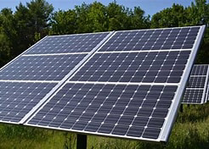

FIG 1.1 SOLAR PANEL

A solar panel is a device that converts sunlight into electricity by using photovoltaic cells. PV cells are made of materials that generate electrons when exposed to light.

The electrons flow through a circuit and produce direct current electricity, which can be used to power various devices or stored in batteries. Solar panels are also known as solar cell panels, solar electric panels, or PV modules.to form a solar array.

A complete photovoltaic system may consist of many solar panels, a power system for accommodating different electrical loads, an external circuit, and storage [batteries](https://www.britannica.com/technology/battery-electronics). Photovoltaic systems are broadly classifiable as either stand-alone or grid-connected systems.

3

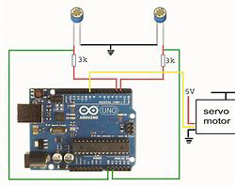

FIG 1.2 ARDUINO CONNECTION

The Rotating Solar Panel Using Arduino project aims at with power supply with the help of a Solar Panel mounted on platform which can rotate with the help of a motor.

This motor is getting controlled by Arduino mounted on an Arduino Uno Board which is in turn mounted by sensing the sunlight. The Rotating Solar Panel system scans from one horizon to other to know the current position of sun and hence the position from which the greater solar energy can be harnessed.

The position which has the highest energy capacity that store the maximize energy. In this way we can harness the most of from the Solar panel by adjusting it to be incident directly towards Sun consistently. Thus this project makes this process of harnessing solar energy more efficent and hence smarter.

4

In our project, solar panel that to store the high energy by adjusting his position towards sun.

The biggest crisis we are heading into is the climate change due to excessive use of fossil fuels and to overcome these issues, we have only one solution that is utilizing Renewable Energy.

Renewable energy is a type of energy that is harnessed from the nature without causing ill effects to the environment. One of the most prominent kind of renewable energy is solar energy.

Solar radiation from the sun is collected by the solar panels and converted into electrical energy. The output electrical energy depends on the amount of sunlight falling on the solar panel.

5

**CHAPTER 2**

**WORKING PROCESS**

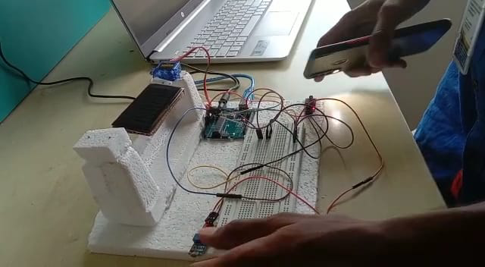

FIG 2.1 WORKING RIGHT SIDE

You must be wondering how does it work? As discussed earlier, the solar panel should face the sun to harness maximum power. So, our system has two steps, first is to detect the position of sun and second is to move along with it.

**Detecting the position of the Sun:**

We measure the intensity of light with LDRs using Arduino and compare the intensity of light falling on both LDRs. The LDRs are placed on the edges of the solar panel as shown in the figure below. Based on the intensity of light on the LDR, we give the signal to the servo motor to cause the movement. When the intensity of the light falling on the right LDR is more.

6

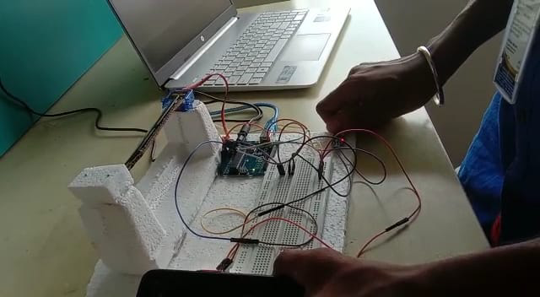

FIG 2.2 WORKING LEFT SIDE

Consider a scenario of a beautiful winter morning, the sun rises from east side and therefore it has more light intensity than the west side, so the panel moves towards to east side. Throughout the day it will track the sun and by the evening, sun has moved towards the west, hence it will have more intensity than the east direction so the panel will face the west direction.

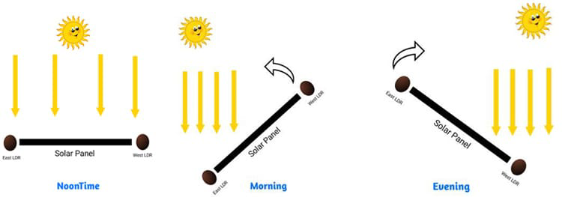

FIG 2.3 FULL SIDE WORKING PROCESS

7

Servo motor is used to rotate the solar panel. We are using servo motor because we can control the position of our solar panels precisely and it can cover the whole path of sun. We are using a servo motor that can be operated with 5volt.

The connection of the circuit is very straightforward. Here, I used an Arduino Uno as controller and connected the 2 LDRs to analogue pin A0 and A1 respectively. Pin 9 of Arduino is connected to the servo motor. Since, we have used a 5V servomotor, we don’t require any external power supply because all the components can easily be powered the Arduino itself. All the connections are shown in the figure

**Light Dependent Resistor (LDR):**

A light-dependent resistor is made from semiconductor material having light-sensitive properties and hence are very sensitive to light. The resistance of LDR changes according to the light that falls on it and it is inversely proportional to the intensity of light. That is resistance of the LDR will increase at high-intensity light and vice versa.

8

**2.2 PROBLEM STATEMENT**

A statement That Discusses What the Problem is Solar panels are of fixed TypE which lower the efficiency Project Scope is to Maximize the power output of the solar panel.

**Sunlight Optimization**: The solar panel system should continuously track the movement of the sun throughout the day and adjust its position accordingly to ensure maximum exposure to sunlight. This requires accurate and real-time tracking of the sun's position relative to the solar panel.

**Precision and Reliability**: The tracking system should be able to accurately determine the sun's position and make precise adjustments to the solar panel's orientation. It should take into account various factors such as the time of day, geographic location, and seasonal variations to ensure optimal alignment with the sun.

**Energy Efficiency**: The tracking system should be designed to minimize power consumption while maximizing energy output. It should be able to efficiently control the movement of the solar panel, using energy-saving mechanisms such as sleep modes and intelligent tracking algorithms to conserve power.

**Environmental Adaptability**: The system should be able to operate in various environmental conditions, including cloudy or partially shaded areas. It should be capable of detecting and responding to changes in lighting conditions, ensuring that the solar panel is always positioned for optimal sunlight exposure.

9

**Cost-Effectiveness**: The tracking system should be cost-effective, utilizing affordable and easily accessible components, such as Arduino microcontrollers, sensors, and motors. It should be scalable, allowing for the integration of additional solar panels without significant increases in cost or complexity.

10

**CHAPTER 3**

**PROBLEM SOLUTION**

It keeps the panel in front of sun until that is visible.The unique feature of this system is that instead of taking the earth as its reference, it takes the sun as a guiding source.

**Sun Tracking Algorithm:** Develop a sophisticated sun tracking algorithm that takes into account the time of day, geographic location, and seasonal variations. This algorithm should accurately determine the sun's position and calculate the optimal orientation for the solar panel to maximize sunlight exposure.

**Sensor Integration**: Incorporate high-precision light sensors to detect the intensity and direction of sunlight. These sensors should provide real-time data to the tracking system, enabling it to make precise adjustments to the solar panel's position.

**Actuator System:** Use efficient and durable motors or actuators to control the movement of the solar panel. These actuators should be capable of making smooth and precise adjustments to align the panel with the sun's position as determined by the tracking algorithm.

**Power Optimization**: Implement intelligent power-saving mechanisms to minimize energy consumption. For example, the system can utilize sleep modes during periods of low sunlight intensity or when the solar panel is already properly aligned

11

**3.1 BLOCK DIAGRAM**





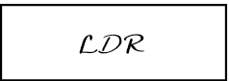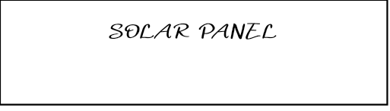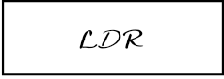



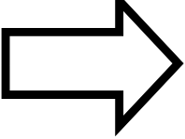

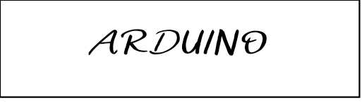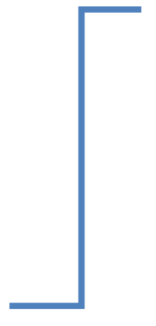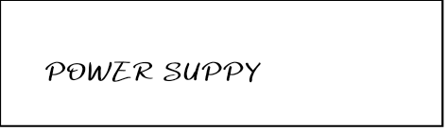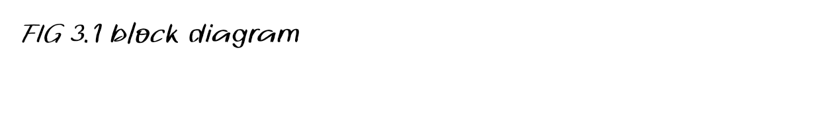

**3.2 CIRCUIT DIAGRAM**

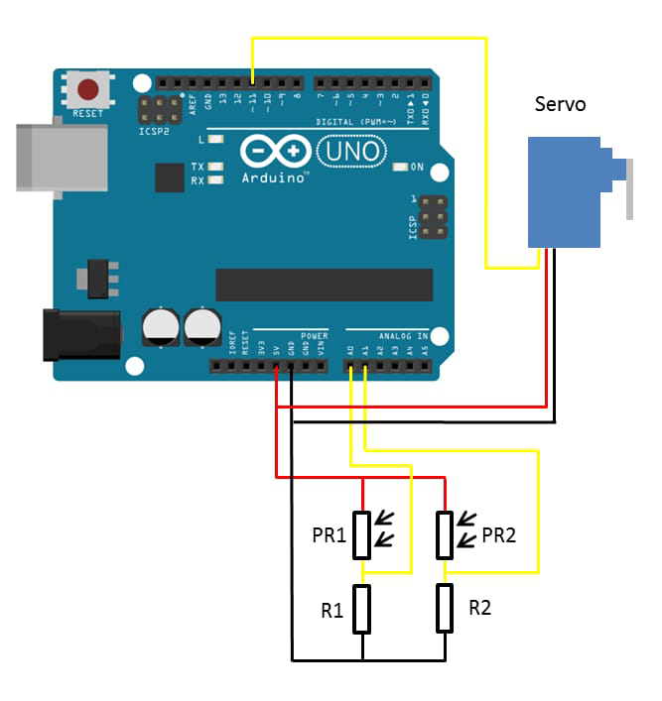

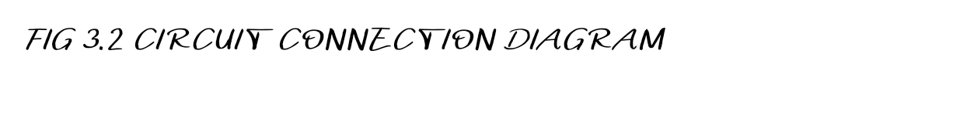

**ABOUT THE CONNECTIONS**

The connection of the circuit is very straightforward. Here, I used an Arduino Uno as controller and connected the 2 LDRs to analogue pin A0 and A1 respectively. Pin 9 of Arduino is connected to the servo motor. Since, we have used a 9g servomotor, we don’t require any external power supply because all the components can easily be powered the Arduino itself. All the connections are shown in ABOVE CIRCUIT.

13

**CHAPTER 4**

**HARDWARE DESCRIPTION :**

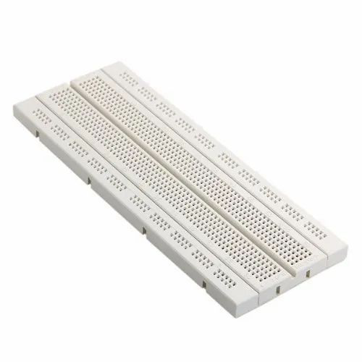

FIG 4.1 BREAD BOARD

A breadboard is a solderless device for temporary prototype with electronics and test circuit designs. Most electronic components in electronic circuits can be interconnected by inserting their leads or terminals into the holes and then making connections through wires wherever appropriate.

14

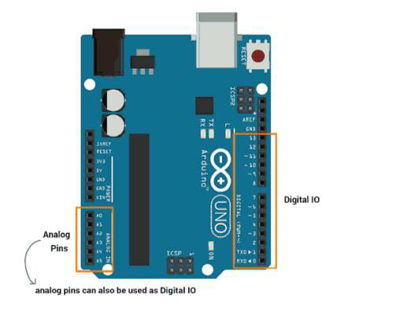

FIG 4.2 ARDUINO

The Arduino Um is an open-source microcontroller bourd based on the Microchip ATmega328P microcontroller and developed by Arduino cc. The board is equipped with sets of digital and analog input/output pins that may be interfaced to various expansion bounds and other circuits.

We have to dumb the code through the software platform “ÄRDUINO IDE”.

15

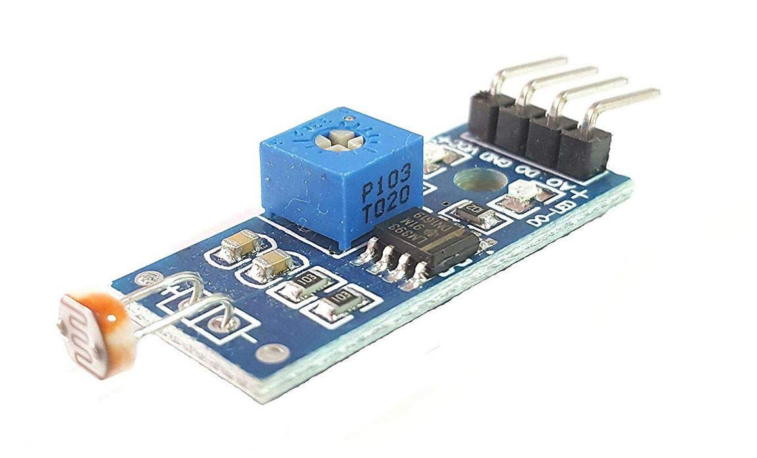

FIG 4.3 LDR MODULE

LDR sensor module is used to detect the intensity of light. It is associated with both analog output pin and digital output pin labelled as AO and DO respectively on the board. When there is light, the resistance of LDR will become low according to the intensity of light.

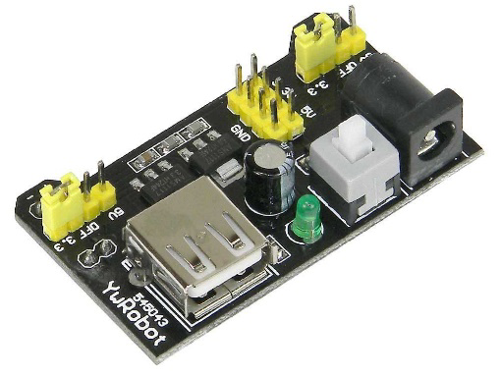

FIG 4.4 Power supply

This power supply board is designed to plug into a Breadboard panel with 2 power Distribution strips. The module can be powered by a USB port or an Adaptor pin.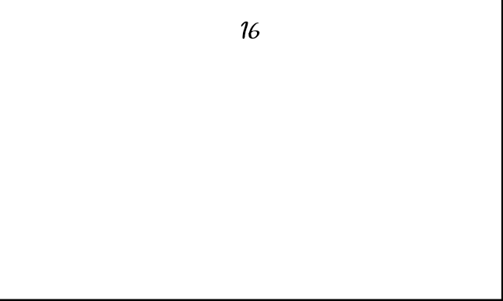

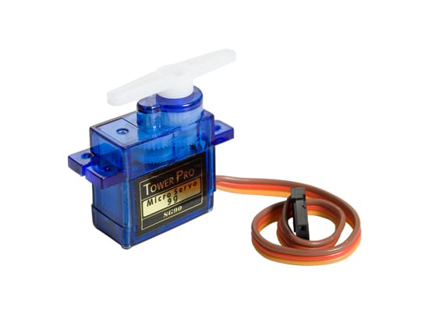

FIG 4.5 Servo Motor

SG90 is a popular micro servo motor commonly used in hobbyist and DIY projects. It is a small, low-cost servo motor that can rotate 180 degrees with a maximum torque of 1.8 kg-cm. It operates at 4.8-6V and has a weight of approximately 9 grams, making it ideal for small-scale robotics and model control applications.

17

**CHAPTER 5**

**SOFTWARE DESCRIPTION**

5.1 PLATFORM USED :



FIG 5.1 ARDUINO IDE

The Arduino Integrated Development Environment - or Arduino Software (IDE) - contains a text editor for writing code, a message area, a text console, a toolbar with buttons for common functions and a series of menus. It connects to the Arduino hardware to upload programs and communicate with them.

In this section, we will dedicate some time to learn about some fundamentals in electronics, and about the basic operation of an Arduino board.

* Anatomy of an Arduino Board.
* Basic Operation.
* Circuit Basics.
* Serial Communication Protocols.

**5.2 CODE STRUCTURE**

ARDUINO CODE FOR SUNLIGHT TRACKING SOLAR PANEL

//Include the servo motor library

#include <Servo.h>

//Define the LDR sensor pins

#define LDR1 A0

#define LDR2 A1

//Define the error value. You can change it as you like

#define error 10

//Starting point of the servo motor

int Spoint = 90;

//Create an object for the servo motor

Servo servo;

void setup() {

//Include servo motor PWM pin

servo.attach(11);

//Set the starting point of the servo

servo.write(Spoint);

delay(1000);. 19

}

void loop() {

//Get the LDR sensor value

int ldr1 = analogRead(LDR1);

//Get the LDR sensor value

int ldr2 = analogRead(LDR2);

//Get the difference of these values

int value1 = abs(ldr1 - ldr2);

int value2 = abs(ldr2 - ldr1);

//Check these values using a IF condition

if ((value1 <= error) || (value2 <= error)) {

} else {

if (ldr1 > ldr2) {

Spoint = --Spoint;

}

if (ldr1 < ldr2) {

Spoint = ++Spoint;

}

}

//Write values on the servo motor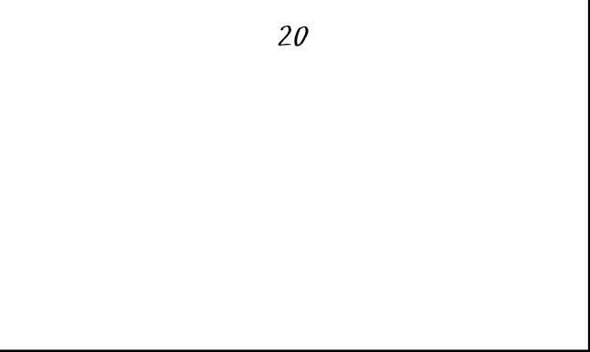

servo.write(Spoint);

delay(80);

}

f. Delay: `delay(80)

**CHAPTER 6**

**RESULT AND IMPLEMENTATION**

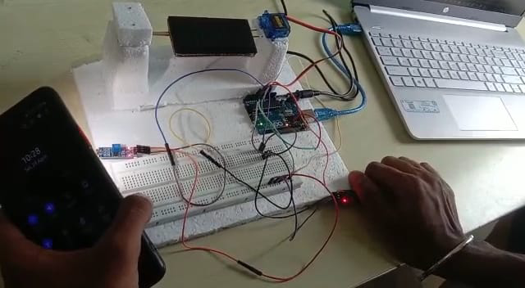

FIG 6.1 FINAL OUTPUT

THIS THE PROTOTYPE OF OUR PROJECT,IS IT TESTED IN DAILY LIFE USAGE FOR MULTIPLE TIMES AND WE SUCCEEDED IN THE RESULTS.THE AIM OF THE PROJECT IS TO MAXIMIZE THE POWER OF SOLAR ENERGY HAS SUCCESSFULLY CREATED,TESTED,IMPLEMENTED.THIS SYSTEM WILL EXPAND WITH MORE FACILITES AND ADVANCE FEATURES IN FUTURE.

21

**6.1 BENEFITS**

Solar panel has been used increasingly in recent years to convert solar energy to electrical energy. The solar panel can be used either as a stand-alone system or as a large solar system that is connected to the electricity grids. The earth receives 84 Terawatts of power and our world consumes about 12 Terawatts of power per day. We are trying to consume more energy from the sun using solar panel. In order to maximize the conversion from solar to electrical energy, the solar panels have to be positioned perpendicular to the sun. Thus the tracking of the sun’s location and positioning of the solar panel are important. The goal of this project is to design an automatic tracking system, which can locate position of the sun. The tracking system will move the solar panel so that it is positioned perpendicular to the sun for maximum energy conversion at all time. Photoresistors will be used as sensors in this system. The system will consist of light sensing system, microcontroller, gear motor system, and a solar panel. Our system will output up to 40% more energy than solar panels without tracking systems

* IT maximize the energy conversion.
* IT adjust his position towards the sun.

22

**REFERENCE**

* [**https://srituhobby.com**](https://srituhobby.com)
* https://youtu.be/YC4kIGQYld4

**23**